**ROAD ACCIDENT REPORT SQL QUERIES**

**CY Casualties**

SELECT SUM(number_of_casualties) as CY_Casualties

from road_accident

where year(accident_date)='2022'

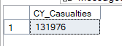

**CY Accidents**

SELECT count(distinct accident_index) as CY_Accidents

from road_accident

where year(accident_date)='2022'



**CY Fatal Casualties**

SELECT sum(number_of_casualties) as CY_Fatal_Casualties

from road_accident

where year(accident_date)='2022' and accident_severity = 'Fatal'



**CY Serious Casualties(the same for Slight)**

SELECT sum(number_of_casualties) as CY_Serious_Casualties

from road_accident

where year(accident_date)='2022' and accident_severity = 'Serious'

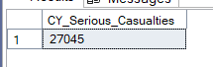

**PCT Slight casualties( same for fatal and serious)**

select cast(sum(number_of_casualties) as decimal(10,2)) *100 /

(select cast(sum(number_of_casualties) as Decimal(10,2)) from road_accident) as PCT

from road_accident

where year(accident_date)='2022' and accident_severity = 'Slight'



**Casualties by Vehicle Type**

Select

case

when vehicle_type in ('Agricultural vehicle') then 'Aricultural'

when vehicle_type in ('Motorcyle 125cc and under','Motorcycle 50cc and under','Motorcycle over 125cc and up to 500cc','Motorcycle over 500cc','Pedal cycle') then 'bike'

when vehicle_type in ('Bus or coach (17 or more pass seats)','Minibus(8 - 16 passenger seats)') then 'Bus'

when vehicle_type in ('Goods 7.5 tonnes mgw and over','Goods over 3.5t. and under 7.5t','Van / Goods 3.5 tonnes mgw or under') then 'Van'

Else 'Other'

end as vehicle_group,

Sum(number_of_casualties) as CY_Casualties

From road_accident

where year(accident_date)='2022'

group by

case

when vehicle_type in ('Agricultural vehicle') then 'Aricultural'

when vehicle_type in ('Motorcyle 125cc and under','Motorcycle 50cc and under','Motorcycle over 125cc and up to 500cc','Motorcycle over 500cc','Pedal cycle') then 'bike'

when vehicle_type in ('Bus or coach (17 or more pass seats)','Minibus(8 - 16 passenger seats)') then 'Bus'

when vehicle_type in ('Goods 7.5 tonnes mgw and over','Goods over 3.5t. and under 7.5t','Van / Goods 3.5 tonnes mgw or under') then 'Van'

Else 'Other'

End

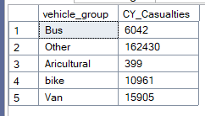

**CY casualties Monthly**

select datename(month,accident_date) as Month_Name,

sum(number_of_casualties)

from road_accident

where year(accident_date)='2022'

group by datename(month,accident_date)

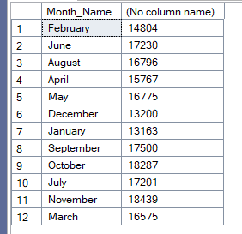

**CY Casualties by Road Type**

select road_type, sum(number_of_casualties) as CY_Casualties

from road_accident

where year(accident_date)='2022'

group by road_type

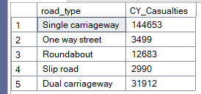

**PCT Casualties by Area**

select urban_or_rural_area, sum(number_of_casualties) as CY_casualties,cast(sum(number_of_casualties)as decimal(10,2)) * 100 /

(select cast(sum(number_of_casualties)as decimal(10,2)) from road_accident

where year(accident_date)='2022') as PCT_casualties

from road_accident

where year(accident_date)='2022'

group by urban_or_rural_area

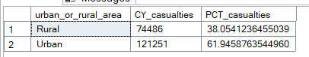

**Casualties by Light Condition**

select

case

when light_conditions in('Daylight') then 'Day'

when light_conditions in('Darkness - lighting unknown','Darkness - lights lit','Darkness - lights unlit','Darkness - no lighting') then 'Night'

end as Light_Condition,

cast(cast(sum(number_of_casualties) as decimal(10,2)) *100 /

(select cast(sum(number_of_casualties) as decimal(10,2)) from road_accident

where year(accident_date)='2022') as decimal(10,2))

as CY_Casualties_PCT

from road_accident

where year(accident_date)='2022'

Group by

case

when light_conditions in('Daylight') then 'Day'

when light_conditions in('Darkness - lighting unknown','Darkness - lights lit','Darkness - lights unlit','Darkness - no lighting') then 'Night'

end

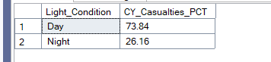

**Top 10 Locations by Total Casualties**

select top 10 local_authority, sum(number_of_casualties) as Total_Casualties

from road_accident

group by local_authority

order by Total_Casualties Desc

